Author – Prateek Gupta

Date – 28/Oct/2020

Hi Team,

I have used the below solution to resolve the problem statement with given set of requirements.

**Problem Statement –**

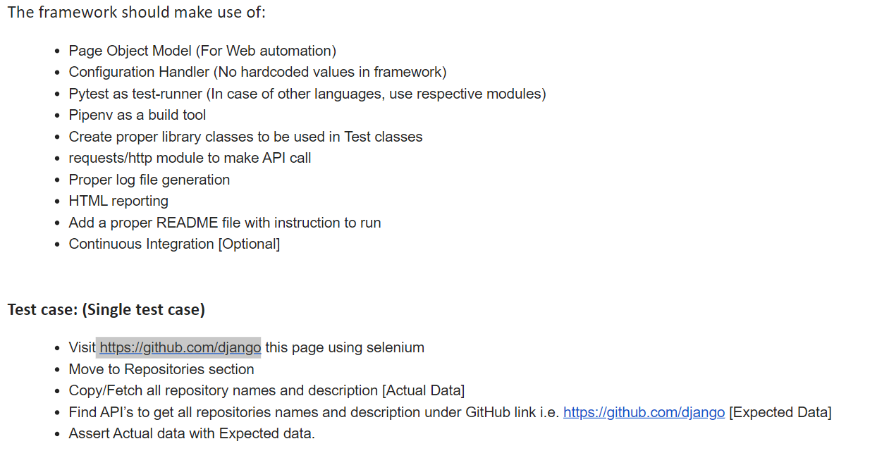

**Solution –**

1. Using the POM design pattern with TestNG framework, I have used the selenium driver to open the URL ( <https://github.com/django>) and get the all the details for repositories with findElements
2. Stored all the Repositories names data in Arraylist as actual data baseline which we was validated later with API Response
3. Using the Rest Assured, I used the get method to to get the Repositories names and validate JSON response for particular API End Point (<https://api.github.com/users/django/repos>)
4. Using JSON parser, I get the attribute value (“name”) for all set of data which is coming in GET JSON response
5. Store the All API data (only Name of Repository) in the Arraylist for future validation
6. As Web interface has different sequencing of reporisty name hence I sorted both the Arraylist (API And Web) to easy comparison
7. As per problem statement, our objective was to validate the count and name of repository which is working in solution and printed in Extent Report

**Reference Test Execution Result -**

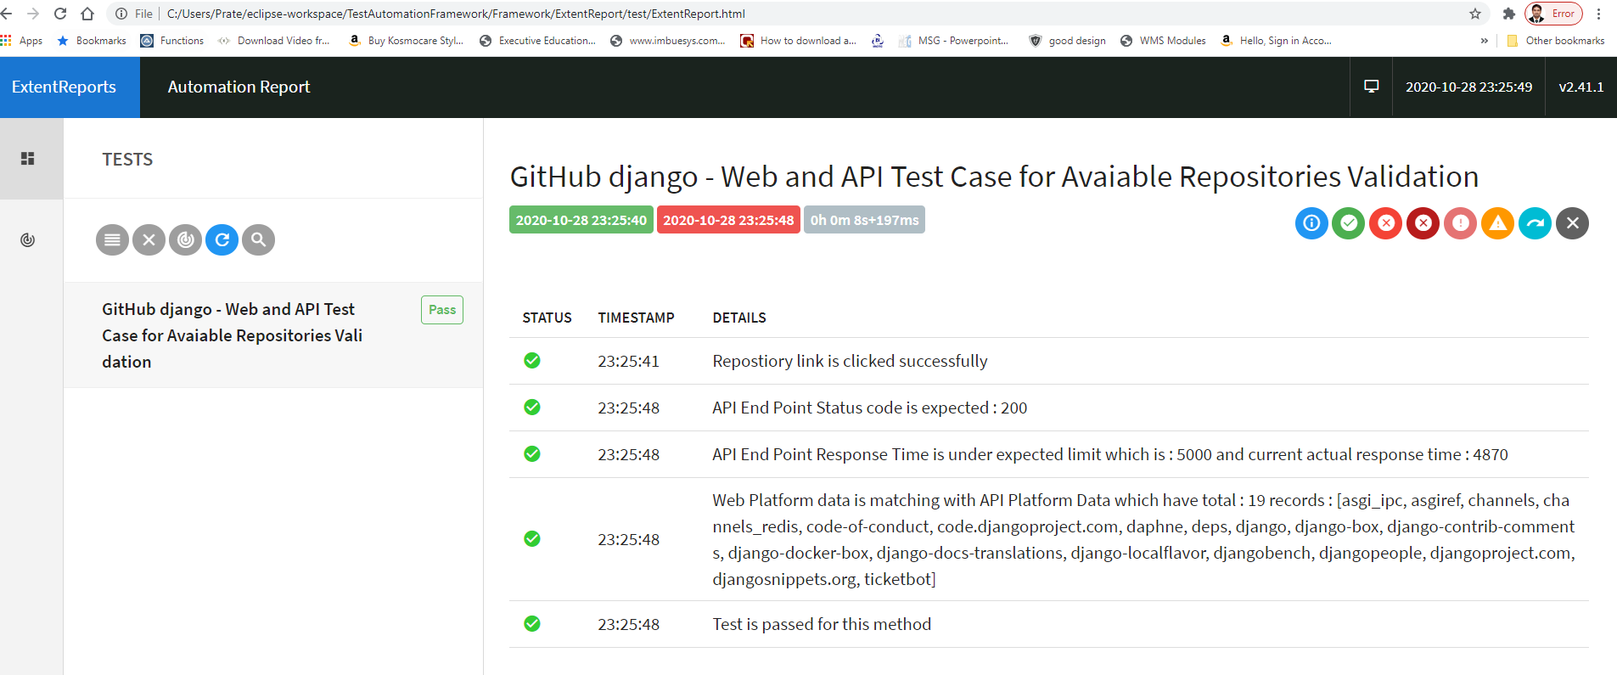

Code Logic Implementation

